2.0 (Four Great Vows, Lesson Two)
Sentient beings are numberless,
We vow to save them all.

四 弘 誓 願
衆 生 無 邊 誓 願 度
煩 惱 無 盡 誓 願 斷
法 門 無 量 誓 願 學
佛 道 無 上 誓 願 成
2.1 (Four Great Vows, Lesson Two)
Each Vow follows the same 4-part pattern:
1. 2 characters describe what the vow is about.
2. 2 characters (starting with 無) modify the first two.
3. 誓 願: the next two characters are always the same
4. The final character is the Vow itself.

The first Vow:
1. 衆 生 = sentient beings
What the vow is about.

2. 無 邊 = without limit
Describing the first two characters.

3. 誓 願= I/we vow

4. 度 = save/liberate/ferry across
2.2 (Four Great Vows, Lesson Two)
衆 生 = sentient beings
From the Digital Dictionary of Buddhism:
A being; living being; all living beings. This term has pre-Buddhist roots in the Chinese classics, such as the Liji and Zhuangzi. It was used to translate the Sanskrit sattva सत्त्व.

"All living things must die."
衆生必死. (The "Book of Rites" 禮記, Liji)

"Fullfillment of nature is the proper goal of all living things. "
幸能正生、以正衆生. (Zhuangzi, 莊子)
2.3 (Four Great Vows, Lesson Two)
As early as the 1750's the phrase "sentient beings" is found in the English translation of Rousseau's "Discourse on Inequality":

".... so long as he does not resist the internal impulse of compassion, he will never hurt any other man, nor even any sentient being, except on those lawful occasions on which his own preservation is concerned and he is obliged to give himself the preference. By this method also we put an end to the time-honoured disputes concerning the participation of animals in natural law: for it is clear that, being destitute of intelligence and liberty, they cannot recognise that law; as they partake, however, in some measure of our nature, in consequence of the sensibility with which they are endowed, they ought to partake of natural right; so that mankind is subjected to a kind of obligation even toward the brutes. It appears, in fact, that if I am bound to do no injury to my fellow-creatures, this is less because they are rational than because they are sentient beings: and this quality, being common both to men and beasts, ought to entitle the latter at least to the privilege of not being wantonly ill-treated by the former."
2.4 (Four Great Vows, Lesson Two)
• 衆 = 血 + 乑
zhòng/many = xuè/blood + zhòng /multitude

• 衆 = multitude, throng; manifold, numerous; sundry, diverse

• 血 = blood; sanguinary; blood-ties; tears so grievous they are bloody; blood-red in color

• 乑 = very uncommon character

• 血 = 丿 + 皿 (mǐn/plate/vessel)
2.5 (Four Great Vows, Lesson Two)
• 生 = 土 + 𠂉
shēng/birth = tǔ/earth + rén/person

• 生 = live, be alive, exist; living being; the act of living; to bring into existence, give birth to; fresh, green, ripe; nature, natural instinct, inherent character
• 土 = earth; soil; land, ground; native land, homeground; local, common, rustic; God of the soil; one of the five agents/elements/phases of 五行 (wǔxíng)
2.6 (Four Great Vows, Lesson Two)
• 𠂉 (rén) = person, human being, man, mankind, humankind; others, the other ones

𠂉 is a radical form of 人. More specifically it is the top radical form. The left radical form (much more frequently seen) is: 亻

𠂉 = 人 = 亻= person

人 appears both on its own and as a component.
2.7 (Four Great Vows, Lesson Two)
• 無 = 𠂉 + 卌 + 一 + 灬
wú/no = rén/person + xì/forty + yī/one + huǒ/fire

• 無 = to be without, to lack; to have nothing; nothing; rhetorically dismissive negative
• 卌 more commonly written: 四十
• 灬 is bottom radical form of 火
• 火 (huǒ) = fire; fiery, ablaze; to start a fire, enkindle; torch, firebrand; one of the five elements of 五行 (wǔxíng)
2.8 (Four Great Vows, Lesson Two)
• 邊 = 辶 + 臱
biān/boundary = chuò/walk + mián/look into distance

• 辶 = to walk, radical form of 辵
• 臱 is uncommon, but has three common components:

臱

自 • zì / oneself

穴 • xué / hole

方 • fāng / upright

觀 自 在 = "kwan ja jae" is the name of Avalokitesvara in the Heart Sutra
2.9 (Four Great Vows, Lesson Two)
How 臱 is put together.
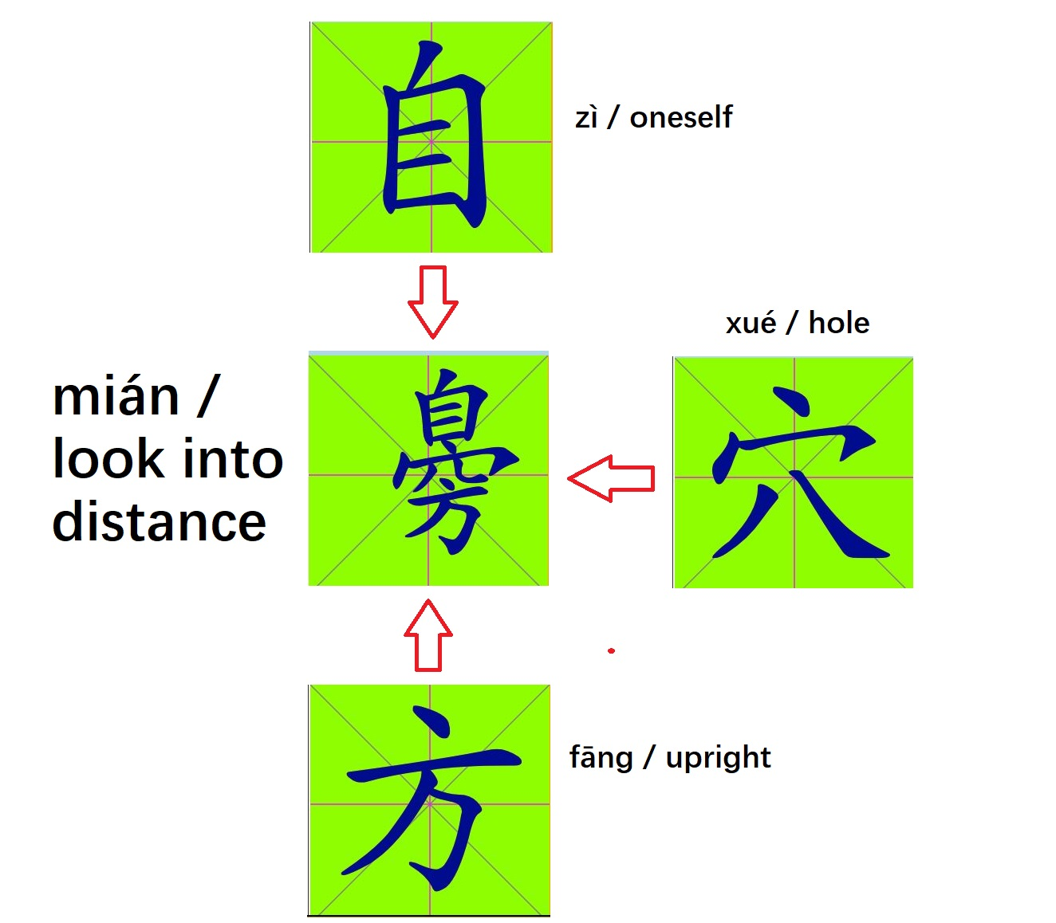

Notice that each individual component/character fits inside a square, and then when they are combined, the combination still must fit inside the same sized square.
2.10 (Four Great Vows, Lesson Two)
度 = 广 + 廿 + 又
dù/save = guǎng/vast + niàn/twenty + yòu/again

What does 度 (dù) really mean??
From the Digital Dictionary of Buddhism (www.buddhism-dict.net):
度 Pinyin: dù ; Hangul: 도 ; Katakana: ド
to cross over (to the shore of liberation)
- To ferry over; to save. To save sentient beings; equivalent to 渡 and 滅度. (Skt. nayati, pramokṣa, uttarana). [resp. cmuller; ref. JEBD]
- The perfection(s), a Chinese translation of pāramitā 波羅蜜. [resp. cmuller]
- To leave home and seek the way; to leave the world as a monk or nun, such as 度得 or 度者. (Skt. mocayati; kṛtvas; vitasti; atikrama, atikramya, atināmayati, atyaya, abhyuddharaṇa, avagāhana, avataraṇatā, uttara, uttaraṇa, uttāraṇa, uttārayati, uttīrṇa, uddharati, upasthāpayati, upasthāpita, otārenti, krama, tāyaṇa, tāyin, tāraṇa, tārayati, tīraṇa, tīrṇa, *trāṇa, *trāta, *nistāra, nistīraṇatā, parâyaṇa, paritrāṇa, paritrāṇatā, paripāka, paripācita, parimita, parimocana, parimocayati, parimocita, pāra-ga, pāra-gata, pratārayati, pratyutīrṇa, pravrajana, pravrājayati, mokṣa, mocana, yāta, vikrānta-gāmin, vinaya, vinivarti, vipramukta, vimukta, vimokṣin, vimocayati, vaineyika, vyatikrama, vyāvṛtya, saṃcāra, samatikrama, samatikramaṇa) [resp. cmuller; source(s): Soothill, Hirakawa]
2.11 (Four Great Vows, Lesson Two)
OK, but what (if anything) does 度 mean in modern Chinese to people who aren't necessarily Buddhist?

From HSK.Academy/en/:

度dù
- to pass
- to spend (time)
- measure
- limit
- extent
- degree of intensity
- degree (angles, temperature etc)
- kilowatt-hour
- classifier for events and occurrences
- HSK 4: 速度 (sù dù) speed; rate; velocity
2.12 (Four Great Vows, Lesson Two)
Characters:
衆, 生, 度, 誓, 願

Components:
血, 乑, 亻, 人, 土, 𠂉, 卌, 灬, 辶, 臱, 穴, 方, 广, 廿, 又

"Extra" Characters:
囚, 什, 但, 牛, 工, 米, 糕, 近, 店, 黃
2.13a (2.13a-2.13b replace 2.13) (Four Vows, Lesson Two Revised)
• 囚 = 囗 + 人
qiú/prisoner = wéi/circle + rén/person

• 什 = 亻+ 十 (always: 什麼)
shén/what = rén/person + shí/ten (什麼 = shén-me)

• 但 = 亻+ 旦
dàn/only = rén/person + dàn/dawn
• 旦 (dàn/dawn) = 日 (rì/sun) + 一 (yī/one)
• 牛 = 𠂉 + 十
niú/ox = rén/person + shí/ten

• 米 = 丷 + 十 + 八
mǐ/grain = bā/eight + shí/ten + bā/eight
2.13b (2.13a-2.13b replace 2.13) (Four Vows, Lesson Two Revised)
• 近 = 辶 + 斤
jìn/close = chuò/walk + jīn/axe

• 远 = 辶 + 元 ***
yuǎn/far = chuò/walk + yuán/currency

• 店 = 广 + 占
diàn/shop = guǎng/vast + zhān/foretell
• 占 =卜 (bǔ/divination) + 口 (kǒu/mouth)

• When used as a component, 卜 is usually found as ⺊
2.14a (2.14a-2.14b replace 2.14) (Four Vows, Lesson Two Revised)
• 糕 = 米 + 丷 + 王 + 灬

gāo/cake = mǐ/grain + bā/eight + wáng/king + huǒ/fire

• 糕 = 米 + 䒑 + 土 + 灬
gāo/cake = mǐ/grain + cǎo/grass + tǔ/earth + huǒ/fire

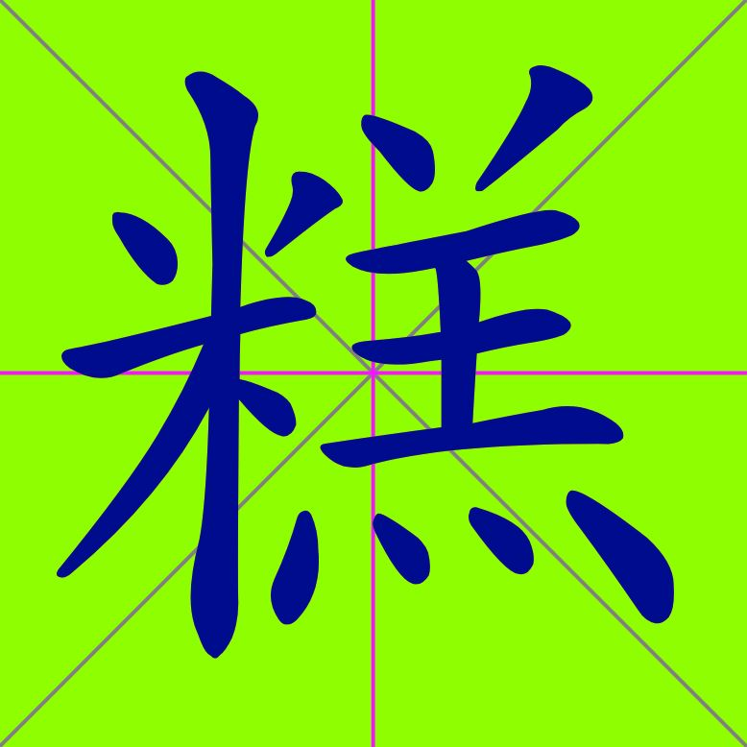
2.14b (2.14a-2.14b replace 2.14) (Four Vows, Lesson Two Revised)
• 黃 = 廿 + 一 + 由 + 八

huáng/yellow = niàn/twenty + yī/one + yóu/cause + bā/eight

• 黃河 = yellow river

• 黃帝 = yellow emperor

• 漢 = 氵+ 𦰩
hàn/Han (Chinese) = shuǐ/water + qín/clay

黃 $≠$ 𦰩 !!!

• 工 = gōng/work (compare: 土, 十)
2.15 (Four Great Vows, Lesson Two)
Where else might you see these characters?

hsk 6: 穴, 誓
hsk 4: 衆 (众), 度
hsk 3: 方, 又, 願 (愿), 糕, 黃
hsk 1&2: 什, 但, 生, 土, 工, 米, 十, 近, 广, 店, 牛

Heart Sutra:
囚, 亻, 人, 旦, 生, 土, 工, 卌, 十, 𠂉, 灬, 辶, 穴, 广, 廿, 又
2.16 (Four Great Vows, Lesson Two)
Recap: The first vow:
衆 生 無 邊 誓 願 度
衆 New character, 3 new components: 血, 乑, 皿
生 New character, 2 new components: 土, 𠂉
無2 new components: 卌, 灬
邊4 new components: 辶, 穴, 方, 臱
誓 New character (old components)
願 New character (old components)
度 New character, 3 new components: 广, 廿, 又

Plus some "extra" characters:
囚, 什, 但, 牛, 工, 米, 糕, 近, 店, 黃
2.17 (Four Great Vows, Lesson Two)

The Four Great Vows in Sino-Korean

四 弘 誓 願 (hanja)
sì hóng shì yuàn (pinyin)
sa hong seo weon (sino-korean)
four great vows (English)

衆 生 無 邊 誓 願 度
zhòng shēng wú biān shì yuàn dù
jung saeng mu byeon seo weon do
all born without limit vow to liberate

2.18 (Four Great Vows, Lesson Two)
煩 惱 無 盡 誓 願 斷
fán nǎo wú jìn shì yuàn duàn
beon noe mu jin seo weon dan
kleśas without end vow to eliminate

法 門 無 量 誓 願 學
fǎ mén wú liàng shì yuàn xué
beob mun mu ryang seo weon hag
dharma gates beyond counting vow to learn

佛 道 無 上 誓 願 成
fú dào wú shàng shì yuàn chéng
bul to mu sang seo weon seong
buddha way nothing higher vow to attain
2.19 (Four Great Vows, Lesson Two)
Sino-Korean is also known as:
漢 字 語
한 자 어
han ja eo
Literally: "Chinese Character Language"
漢 字 / 한 자 / han ja = Chinese Characters

Sino-Japanese is also known as:
漢 語
かんご
kan go
Literally: "Chinese Language"
漢 字 / かんじ / kanji = Chinese Characters
2.20 (Four Great Vows, Lesson Two)
The character 永 (yǒng/forever) contains all eight strokes:

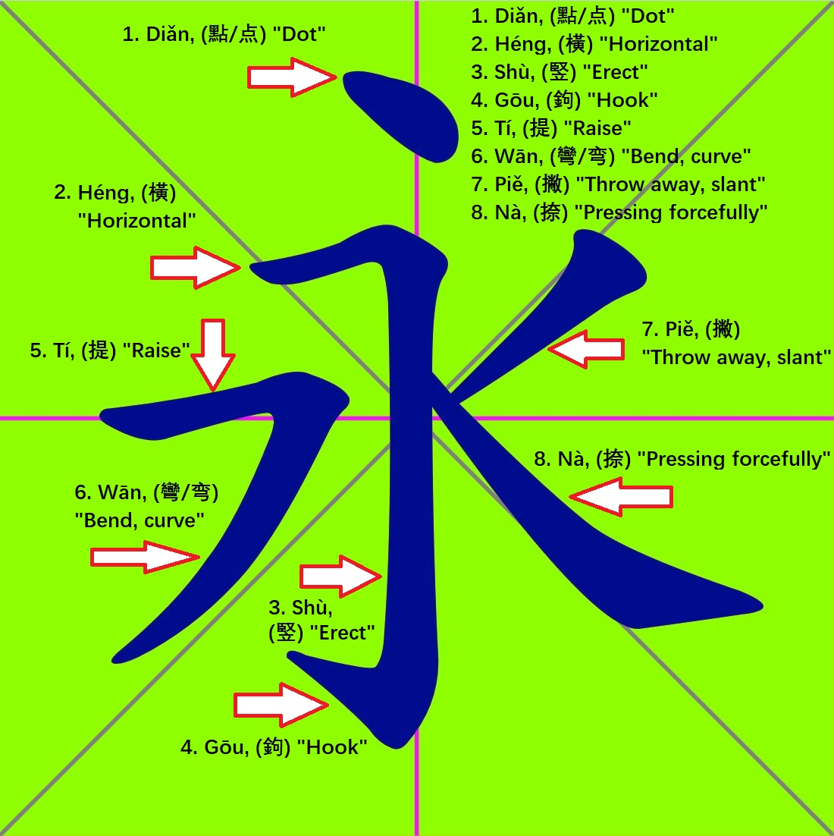
2.21 (Four Great Vows, Lesson Two)
Strokes are the smallest units of a Chinese character. But when learning to recognize and write the characters, components are more useful. Although opinions vary on this.

In addition to strokes and components there are also radicals. The definition of component is much looser than that of radical.

When you learn to recognize radicals (as components of characters) this is useful for looking up a character in a Chinese dictionary, because the characters are often categorized by their radicals. Unfortunately, while a character may have three, four or more components, it can only have one, or at most two radicals. And it isn't always obvious which component of a given character is considered to be it's radical. Confusing? Yes.
2.22 (Four Great Vows, Lesson Two)

Homework:

衆, 血, 乑, 囚, 什, 但, 生, 牛, 土, 工, 米, 卌, 糕, 近, 穴, 方, 度, 廿, 黃, 又, 店, 誓, 願

2.23 (Four Great Vows, Lesson Two)
Vocabulary so far
四, 囗, 儿, 弘, 弓, 厶, 折, 言, 扌, 手, 斤, 口, 原, 頁, 白, 小, 自, 八, 日, 目, 衆, 血, 乑, 囚, 什, 但, 生, 牛, 土, 工, 米, 卌, 糕, 近, 穴, 方, 度, 廿, 黃, 又, 店, 誓, 願

