1.0 (Four Great Vows, Lesson One)

四 弘 誓 願
眾 生 無 邊 誓 願 度
煩 惱 無 盡 誓 願 斷
法 門 無 量 誓 願 學
佛 道 無 上 誓 願 成

1.1 (Four Great Vows, Lesson One)
Practice these 20 characters:

四, 囗, 儿, 弘, 弓, 厶, 折, 言, 扌, 手*,
斤, 口, 原, 頁, 白, 小, 自, 八, 日, 目

Learn to recognize the characters and know what they mean.

Learn to write the characters one stroke at a time.

Learn how the characters are interconnected by composition and decomposition.
1.2 (Four Great Vows, Lesson One)
四 = 囗 + 儿
(sì/four = wéi/circle + ér/child)

One way to "build" a new character is to take one character and put it inside another:

田 = 囗 + 十
日 = 囗 + 一
囟 = 囗 + 乂 + 丿
1.3 (Four Great Vows, Lesson One)
弘 = 弓 + 厶
(hóng/great = gōng/bow + sī/secret)

Another way to build characters is to place two characters side-by side:

法 = 氵 + 去
佛 = 亻 + 弗
但 = 亻 + 旦
1.4 (Four Great Vows, Lesson One)
誓 = 折 + 言
(shì/vow = zhé/break + yán/words)

A third way to build characters is to place one character on top of another:

去 = 土 + 厶
空 = 穴 + 工
旦 = 日 + 一
1.5 (Four Great Vows, Lesson One)
願 = 原 + 頁
(yuàn/desire = yuán/source + yè/page)

This is another example of a character composed of two components placed side by side.

1.6 (Four Great Vows, Lesson One)
Recap:
四 = 囗 + 儿
弘 = 弓 + 厶
誓 = 折 + 言
願 = 原 + 頁
So far that gives us 10 characters (in this lesson we'll skip 誓 & 願 for now).
But wait, there's more .....
1.7 (Four Great Vows, Lesson One)
Now we'll take decomposition a step further:
四 = 囗 + 儿
弘 = 弓 + 厶
誓 = 折 + 言
願 = 原 + 頁

折 = 扌 + 斤 (zhé/break = shǒu/hand + jīn/axe)
扌 = "radical" of 手 (shǒu/hand)

言 = 亠 + 二 + 口
yán/speech = tóu/lid + èr/two + kǒu/mouth
1.8 (Four Great Vows, Lesson One)
四 = 囗 + 儿 (sì/four = wéi/circle + ér/child)
弘 = 弓 + 厶 (hóng/great = gōng/bow + sī/secret)
誓 = 折 + 言 (shì/vow = zhé/break + yán/words)
願 = 原 + 頁 (yuàn/desire = yuán/source + yè/page)

原 = 厂 + 白 + 小
(yuán/source = hǎn/cliff + bái/white + xiǎo/small)
白 = 丿+ 日
bái/white = piě/slash + rì/sun

頁 = 一 + 自 + 八
yè/page = yī/one + zì/oneself + bā/eight
自 = 丿 + 目
zì/oneself = piě/slash + mù/eye
1.9 (Four Great Vows, Lesson One)
Notice that when characters are combined to make new characters, they get squished so that the new combination still fits into the space of a single character:
原 = 厂 + 白 + 小
(yuán/source = hǎn/cliff + bái/white + xiǎo/small)
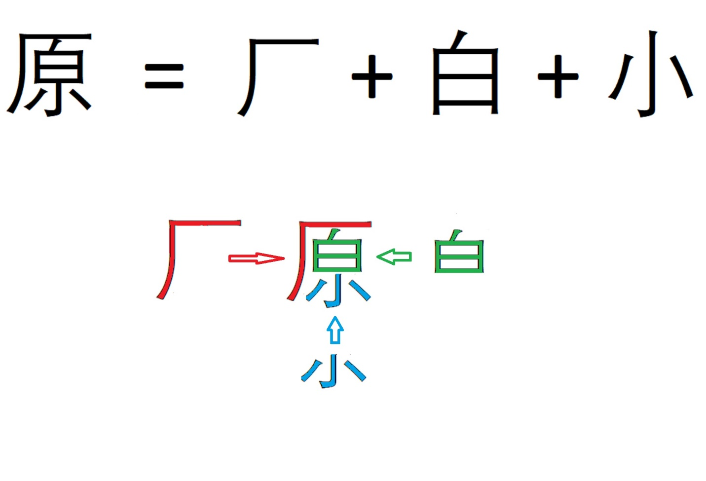

1.10 (Four Great Vows, Lesson One)
Now we have all 20 characters:
四, 囗, 儿, 弘, 弓, 厶, 折, 言, 扌, 手*,
斤, 口, 原, 頁, 白, 小, 自, 八, 日, 目

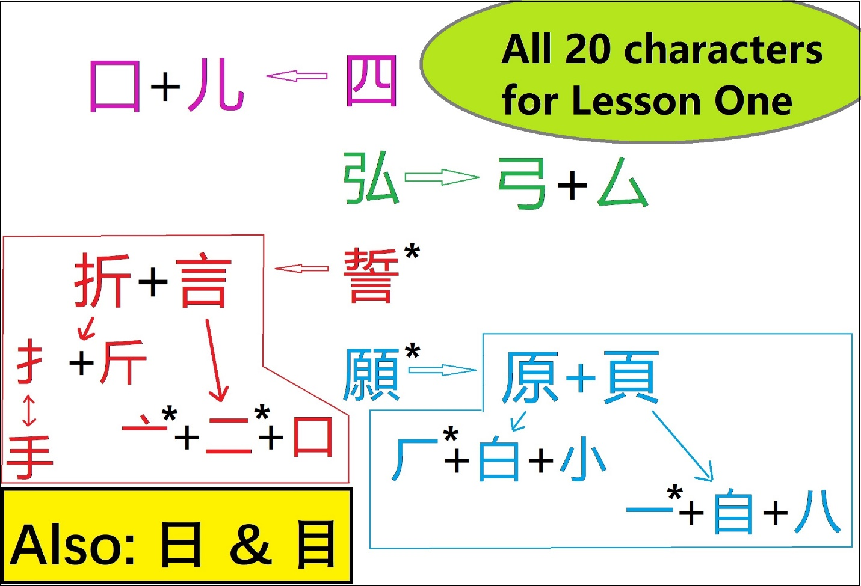

NOTE: characters not included:
誓, 願, 亠, 二, 厂, 一 (These are marked with * in the diagram above)
1.11 (Four Great Vows, Lesson One)
Tricky characters:

- 囗 and 口

- 儿 and 八

- 白, 自, 日, and 目

- Notice that the radical 扌is missing a stroke compared to 手.

1.12 (Four Great Vows, Lesson One)
Where else might you see these characters?

HSK 1 & 2:
四, 囗, 儿, 弓, 厶, 讠(言) , 扌, 手, 斤, 口, 白, 小, 自, 八, 日, 目
(NOT in HSK 1 & 2: 弘, 折, 原, 頁)

Heart Sutra:
囗, 儿, 弓, 厶, 言, 扌, 手, 斤, 口, 頁, 白, 小, 自, 八, 日, 目

